**Lab 7: AC Test Equipment**

**Objective:**

Introduce students to the fundamentals of test equipment commonly used to test and analyze AC circuits.

**Equipment and Components:**

1. DC Power Supply
2. Digital Multimeter
3. Oscilloscope
4. Function Generator
5. Breadboard
6. Resistors: 4.7kΩ, 10 kΩ.
7. Capacitor: 47pF

**Preliminary:**

AC stands for Alternating Current.

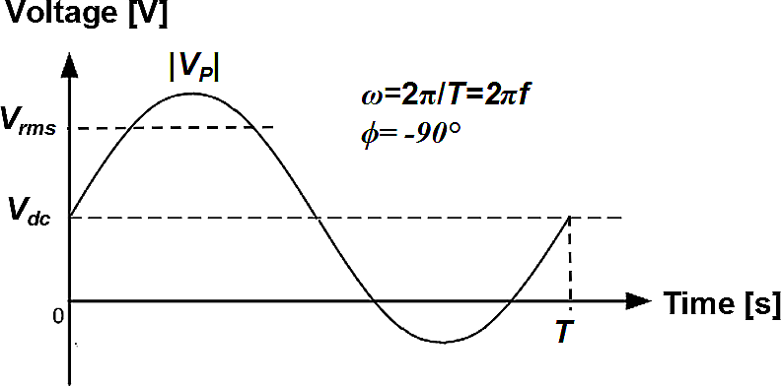

Fig. 7.1: An AC Voltage signal with phase angle *ϕ*= -90°

The general expression for AC signal is given as follows:

**.................................................(1)**

**Instantaneous value:** Usually defined as lower case variable, v(t) shown in eq. 1, it represents the exact value the voltage and/or current has at that moment in time.

**DC offset:** The average value of the AC waveform is known as the DC offset because the AC signal is shifted from zero by that value (in other words, the AC waveform is centered around the DC term or the AC signal is superimposed on the DC signal).

**Peak:** This is the largest value that the signal will experience with respect to common value. For a 0 DC offset signal, it is also commonly called the magnitude of the sine/cosine wave, VP.

**Peak to Peak:** It is the total swing in voltage/current that can be expected. For a 0 DC offset signal it is twice the Peak.

**Period:** It is the time it takes the AC signal to repeat, T.

**Frequency:** It is the number of oscillations in one second. Mathematically, it is the inverse of the period, f = 1/T.

It is also common to convert from cycles/second to radians/second, ω = 2 π f.

**Phase angle:** It is the angle the waveform makes at its origin, **Փ.** It is commonly used to determine how much portion of the waveform has elapsed w.r.t. the origin. In Fig. 1, the phase angle is -90° because the waveform is shifted to the right by a quarter cycle (or 90°).

**Average or Mean:** The DC value, ***Vdc*** or the average value, ***Vavg***, of the AC voltage can be represented by the following equation:

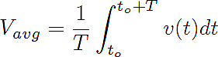**...................................................................(2)**

**RMS: Root Mean Square value**, ***Vrms***, is defined as the equivalent DC value that will dissipate the same average power as the AC voltage over one complete period. Mathematically, it is the root of the mean of the squared instantaneous values.

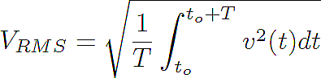**...................................................................(3)**

*For a sinusoidal signal, Vrms comes out to be 0.707 |Vp| + Vdc.*

For example:

* if ***|Vp| = 2* V and *Vdc*= 0 V**, then ***Vrms=(0.707)(2)= 1.414* V*.***
* if ***|Vp| = 2* V and *Vdc*=1 V**, then ***Vrms=(0.707)(2 )+1= 2.414* V*.***

1. Document in your lab book, key notes from the tutorials on function generator and oscilloscope provided in the Appendix.

**Procedure:**

1. Construct a voltage divider with the 4.7 kΩ and the 10 kΩ resistors in series with the function generator as shown in Fig. 2. Set the function generator to produce a 1 kHz sine wave with a peak voltage (amplitude) of 1 V.

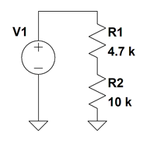

Fig. 7.2: Voltage divider circuit with AC voltage source:

(set amplitude=1V, frequency=1 kHz, DC offset=0 V, phase = 0°)

1. Measure and record the voltage drop across the 4.7 kΩ and 10 kΩ resistor with the multimeter. Use both the DC and AC voltage settings. Display these values in a table and verify that KVL (Kirchhoff’s Voltage Law) is still valid.
2. Now use the oscilloscope and measure the voltage drop across the 4.7 kΩ and 10 kΩ. Sketch the resulting waveforms. Do the waveforms agree with KVL?

***Note1:*** *You may find it difficult to display the waveform across 4.7 kΩ resistor using one probe. Use two probes (make sure to ground them) and measure voltages on the two ends of 4.7 kΩ resistor. Next use the Math function on the o-scope to find the voltage drop (difference).*

***Note2:*** *Adjust the time/div, volts/div, trigger, and positions to get the best reading and record the effects of each adjustment. Remember, the #/div refers to the large divisions seen on the screen.*

1. Calculate the ratio between the Peak voltages measured with the oscilloscope and the RMS values measured with the multimeter for both 4.7 kΩ and 10 kΩ. The ratio should be close to √2 =1.41.
2. Using the oscilloscope, measure the period and the frequency (1/T) of the voltage waveform dropping across the 4.7 kΩ and 10 kΩ resistor (the frequency should be 1 kHz).
3. Now, construct the circuit shown in Fig. 7.3 using a LM348 or equivalent Op-Amp and + /- 15 V power supplies.
4. Apply a 1 V, 1 kHz sinusoidal signal. Using Channel 1 of the oscilloscope to monitor the input voltage and Channel 2 to monitor the output, sketch the resulting display.
5. Identify what mathematical expression the circuit implements. *Hint: Pay close attention to the phase variation between the input and output signals. Also take a note of the output amplitude level.*

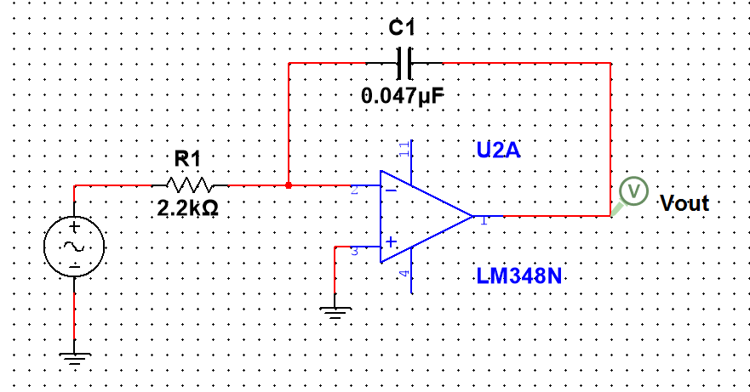

Fig. 7.3: Op-amp circuit with AC voltage source:

(set amplitude=1V, frequency=1 kHz, DC offset=0 V, phase = 0°, probe input and output voltages and describe what function the circuit performs.)

**Conclusion:**

Summarize your findings and discuss the use of multimeter vs. an oscilloscope. In addition, document some of the key concepts that should be known when performing oscilloscope measurements.

**Appendix**

**Function Generator:**

Not all signals are constant (DC sources), many laboratories have function generators that are capable of producing various types of alternating current (AC) voltage signals. The most common signals are sinusoidal, square, triangle, and ramp type voltage sources. Many function generators also provide control over the peak voltage, frequency, and duty cycle of the generated waveform. High quality signal generators also enable the addition of a DC source in series with the AC component to produce a DC Offset.

In many cases, the circuit under test will actually load the generator and distorts the signals, making it difficult for a graphical analyzer /oscilloscopes to lock on to a repeating part of the waveform. To aid in viewing of these waveforms, high end generators also provide a sync signal, a TTL (0-5V) pulse type signal that is synchronized to the “start” of the waveform. This trigger signal can then be connected direct to the triggering part of the oscilloscope to provide repeatable sweeps.

For additional information, view the following tutorials.

* <https://www.youtube.com/watch?v=mLKPwWGBtIw>
* <https://www.youtube.com/watch?v=Zink6v6TXk4>

**Oscilloscope:**

Oscilloscopes are graphical volt-meters that display variations in voltage with respect to time. Many oscilloscopes are also capable of displaying multiple waveforms as well as mathematical combinations of the sensed signals. The most common controls on the oscilloscope are the Vertical (Volts/Division), Horizontal (Seconds/Division), and the Trigger. The vertical control can be used to adjust the display scale of the vertical deviations. This is helpful when viewing signals near the noise floor or strong signals. The horizontal control is used to vary the temporal resolution seen on the screen. The Trigger is used to identify when the oscilloscope should begin recording/displaying the signal and at what interval.

Two very important issues to remember when operating an oscilloscope are:

a) Make sure the probes are calibrated using the internal calibration signal. To do this, connect the probe to the internal square wave source and then adjust the shunt capacitance on the probe until the rising edge of the square wave is as sharp as possible without overshoot.

b) Many probe have a built in 10x amplification factor. Make sure that the multiplying factor presented by the probe matches what the oscilloscope is expecting to see. Otherwise all of your values will be off. If you desire additional information on how to use an Oscilloscope, google “XYZ’s of Oscilloscopes”.

For additional information, watch this tutorial. <https://www.youtube.com/watch?v=Iq4QlfH-oqk>

**Multimeter:**

Multimeters can also be used to measure AC signals. However, when using a multimeter set for AC readings, they are only able to read DC equivalent or RMS value. Some multimeters also have options that enable the DC setting to measure the DC offset, instantaneous value, and a peak hold feature that can be used to find the peak value.

**Power Supply:**

To create + 15 V and -15 V power supplies, connect two floating power supplies in series and use the common node as the reference (ground) point for the circuit (please see the picture shown below).

Make sure that you first measure the output of the power supplies to ensure V+ = 15 V and V- = -15V using Multimeter before connecting them to your circuit. Be careful when you connect the power supplies (high voltage on wrong pins will destroy the op amp). Turn up the voltage slowly from 0 to 15 V. Please make sure that all the grounds in the circuit as well as the ones from the oscilloscope, function generator, and the power supply are connected together as a single ground.

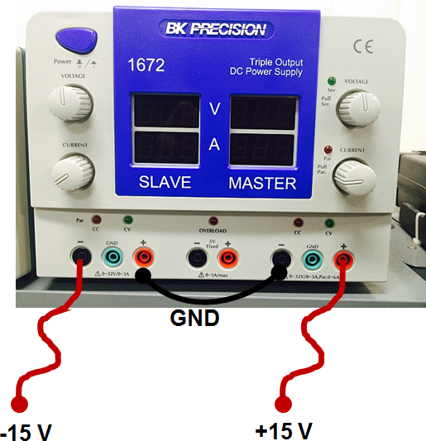

Figure 7.4: Using a DC power supply to generate +15V and -15V.